Methocel Delivery System

Adriaan Riet

Sean Lawry

Austin Smith

October 7, 2014

Table of Contents

Tables and Figures 2

Abstract 3

Introduction 3

Apparatus Design 4

Experimental Procedure 4

Safety 4

Theory and Data 5

Results 7

Data Analysis 7

Sources of Error 10

Conclusions & Recommendations 11

Appendix A 12

Acknowledgement 12

References 12

## Tables and Figures

|  |  |
| --- | --- |
| **Tables** | |
| 1 | *Final Calculations* |
| 2 | *Linear regression for ln(τ) vs. ln(v)* |
| 3 | *Linear regression for (ln(τ)-* *Ω) vs. ln(v)* |

|  |  |
| --- | --- |
| **Figures** | |
| 1 | *Apparatus Design* |
| 2 | *Non-Newtonian Moody Chart* |
| 3 | *Confidence Intervals* |
| 4 | *Plot of Residuals* |

## Abstract

Methocel, a non-Newtonian fluid, is to be pumped from a railway terminal to a nearby plant. A delivery system is already in place, but must be adequate to transport the fluid without exceeding the rupture disk pressure rating (250 psig). An apparatus has been constructed to measure the flow rate and pressure drop of methocel. This apparatus yielded rheological data which was used to determine the adequacy of the transport system. Based on the data, a pressure drop of 81 psig was calculated, which is well below the 250 psig pressure rating.

## Introduction

Methocel must be transported to a new plant from the nearby railway terminal. A delivery system is already in place, and the team’s objective is to determine if it can transport 75 gallons per minute of a 1% (by weight) methocel solution without exceeding the rupture disk pressure rating (250 psig). The company lab contains a system designed to measure flow rate and pressure drop of the methocel solution in two different pipe sizes. The test system can be used to determine the rheology of the fluid, which can then be used to determine the pressure drop of the system in place. Methocel is a known non-Newtonian fluid and must be modeled accordingly. DOW Chemical lists methocel as a pseudoplastic fluid that follows the power law model [Source 1]. This model and the data from the apparatus can be been used to determine the rheological parameters n and K (discussed below) of methocel, as well as the pressure drop in the pipe. The pressure drop through the pipe represents the minimum required pressure at the existing transport system. If the minimum pressure exceeds the rupture disk rating, a new transport system will be designed. The team was also assigned to compare the behavior of methocel solution vs. water.

## Apparatus Design

A large tank with two mixers keeps the 1% methocel solution well-mixed. A computer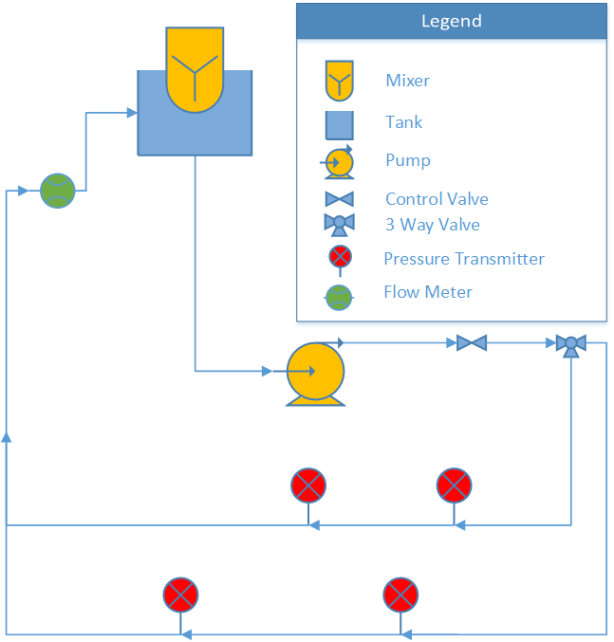 controlled valve maintains a constant flow rate, and a second valve switches between the two pipe sizes. Each of these copper pipes has a pressure transducer that measures pressure drop as a function of distance. The pressure drop and flow rate data are then transmitted to a computer. The computer is set to provide one measurement per second for 100 seconds. Figure 1 diagrams the apparatus.

## Experimental Procedure

The experiment was performed in two pipes of different diameters at ten different flow rates in each pipe. Performing the experiment in two separate pipe sizes allowed for two separate experiments, which could be compared to determine the validity of the data. Each flow rate contains 100 measurements taken at one-second intervals. Randomized experiments minimized any systematic disturbances. Measured variables included the pressure drop across the active pipe, flow rate, the time the reading was taken, pressure drop across the inactive pipe, ambient temperature, ambient pressure, flow set point and the valve controller output.

**Figure 1**- *Apparatus Design*

## Safety

The equipment of the experiment posed potential hazards. There were mixers mixing the solution throughout the lab period. A pump was used to transport the fluid. One of the team members was always observing the tank while the system was running. This was to ensure others would not come into contact with any of the equipment. The pump was turned off as soon as the data collection was completed. The valve that changed the flow from the large to small diameter pipe had to be switched when the pump was off. Because fluids were involved in this experiment, care was taken to minimize any potential electrical hazard. Methocel in solution is not particularly hazardous, but is flammable as a powder. The flammability hazard was low since the experimental material was methocel in solution.

## Theory and Data

It is assumed that methocel is a power law fluid. According to David Lignell’s notes [Source 2], if a fluid follows the power law it will obey equation 1:

|  |  |  |
| --- | --- | --- |
|  | $τ={K(-\frac{dv}{dr})}^{n}$ | (1) |

where $τ$ is shear stress, $K$ and $n$ are empirically determined constants, and $\frac{dv}{dr}$ is the change in velocity per change in radial distance. $τ$ is calculated using equation 2.

|  |  |  |
| --- | --- | --- |
|  | $$τ= -\frac{R}{2}\frac{dP}{dx}$$ | (2) |

which requires the pressure drop (*dP/dx*) and pipe radius (R), both of which are measured. In order to determine $n$ and $K$, equation 3 was used. Equations 4 is defined for simplicity.

|  |  |  |  |  |
| --- | --- | --- | --- | --- |
|  | $$\ln{(τ})=n\ln{(v})+\{\ln{(K})+n\ln{(\frac{2(3n+1)}{nD}})\}$$ | | | (3) |
|  | | $$Ω=n ln(\frac{2\left(3n+1\right)}{nD})$$ | (4) | |
|  | |  |  | |
|  | |  |  | |

By utilizing linear regression of equation 3, $n$ and $K$ were determined. More details on $Ω$ and the regression will be provided in the data analysis section.

$f$, which depends on n and K, was calculated with a modified Reynolds number (Equation 5) and using a non-Newtonian Moody chart [Source 2]. The chart is shown in Figure 2.

|  |  |  |
| --- | --- | --- |
|  | $$Re=\frac{8ρv^{2}}{K}(\frac{nD}{2(3n+1)v})^{n}$$**Figure 2:** *Non-Newtonian Moody Chart* | (5) |

Equation 6, models pressure drop due to friction in a circular pipe.

|  |  |  |
| --- | --- | --- |
|  | $$ΔP=\frac{-fLv^{2}}{2D}$$ | (6) |

where P is pressure, f is the Darcy friction factor, L is the length of the pipe, v is average velocity through the pipe, and D is the inner diameter of the pipe.

In a system using water, the Reynolds number and friction factor are given by equations 7 and 8 [Source 4].

|  |  |  |
| --- | --- | --- |
|  | $$Re=\frac{ρvD}{μ},$$ | (7) |

|  |  |  |
| --- | --- | --- |
|  | (turbulent). | (8) |

Once $f$ was acquired for water, an estimate of the pressure drop was obtained with equation 6.

## Results

The flow behavior index (n) determines the fluid classification. Newtonian fluids have n=1, pseudoplastic fluids n<1, and Bingham plastics n>1. These fluids act differently under shear stress. Pseudoplastic fluids experience a decrease in viscosity with increasing shear stress and Bingham plastics experience an increasing viscosity with a higher shear stress. The calculated n value of 1% methocel was determined to be 0.64 in this experiment. The calculated pressure drop through experimentation was 81.4 psig (Table 3), which is less than the maximum pressure of 250 psig. The pressure drop of water running through the same piping system was calculated at 26 psig.

|  |  |  |  |  |  |  |
| --- | --- | --- | --- | --- | --- | --- |
|  | n | K | Re | f | dP (Pascals) | dP (psig) |
| **small pipe** | 0.59 | 1.21 | 950 | 0.07 | 5.61E+05 | 81.3 |
| **large pipe** | 0.70 | 0.69 | 896 | 0.07 | 5.94E+05 | 86.2 |
| **weighted average** | 0.64 | 0.89 | 949 | 0.07 | 5.61E+05 | 81.4 |

**Table 1:** *Final Calculations*

## Data Analysis

Measurements from each pipe were grouped together. For every data point, pressure drop per length of pipe was calculated from the measured pressure drop and the measured distance between the pressure sensing probes. To determine pipe diameter, the pipe circumference was measured and converted to an outside diameter. This was referenced with literature to obtain the inner diameter of the pipe (which is the diameter used in all referenced equations) [Source 3]. For each data point, an average fluid velocity was calculated from the measured flow rate and the inner pipe diameter. Shear stress was calculated using equation (2) and the calculated pressure drop per length of pipe. With this information, ln(τ) (where τ = shear stress) and ln(v) (where v = avg. velocity) were calculated.

Linear regressions were performed on ln(τ) vs. ln(v) (in the form of equation (3)). Table 2 details these linear regressions. The slope of the regressed line was taken to be a measured value of n. The measured value of n was used to calculate Ω (defined in equation 4). Once Ω was known, K could easily be calculated form the intercept of the graph. In this manner, K and n values were calculated for both pipes. For convenience, equation 4 is repeated here.

|  |  |  |
| --- | --- | --- |
|  | $$Ω=n\ln\left(\frac{2\left(3n+1\right)}{nD}\right)$$ | (4) |

|  |  |  |  |
| --- | --- | --- | --- |
|  |  |  |  |
|  |  |  | Ω |

**Table 2:** *Linear regression for ln(τ) vs. ln(v)*

Another linear regression was performed to reconcile the data on the assumption that the true n and K values were the same for the fluid in both pipes (which should be true for a power law fluid.) In order to do this, a linear regression of (ln(τ) – Ω) vs. ln(v) was used instead of the original in order to use all of the data as a whole. Ω contains the diameter of the pipes. Since the diameter is different for the two pipes, it caused offset between the two lines. This new regression technique solved the offset problem.

**Table 3:** *Linear regression for (ln(τ)-* *Ω) vs. ln(v)*

|  |  |  |  |
| --- | --- | --- | --- |
| $$y$$ | $$m$$ | $$x$$ | $$b$$ |
| $ln\left(τ\right)-Ω$ | $$n$$ | $$ln(v)$$ | $$ln\left(K\right)$$ |

To obtain Ω, the pipe diameter corresponding to each data point was used, and n was calculated iteratively. Confidence intervals were plotted in figure 3, and residuals were plotted in Figure 4. 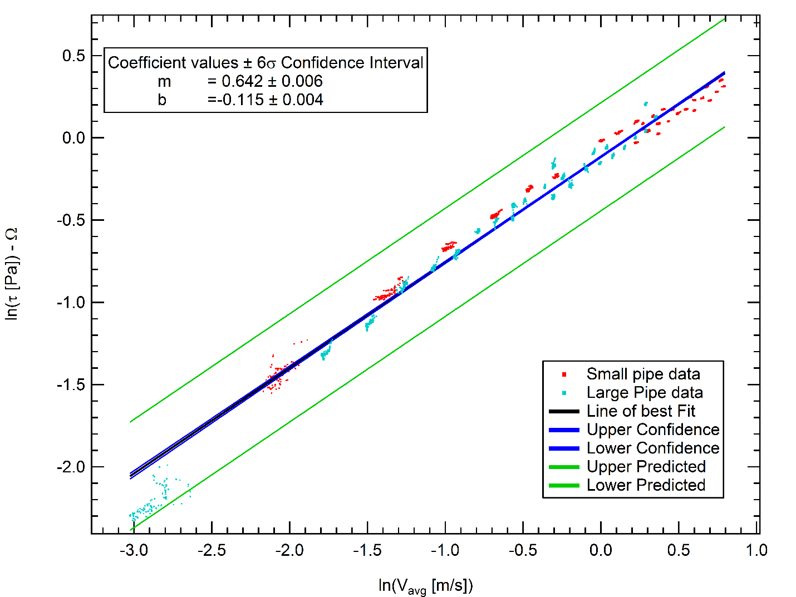

**Figure 3:** *Confidence Intervals*

**Figure 4:** *Plot of Residuals*

There was some initial concern about the cluster of data in the bottom left of both the confidence and residual plots. These points correspond to very low flow rates in the large pipe. The data was taken to ensure that the pressure/shear relation went to zero in the limit of no flow, and was taken at a much lower flow rate than the rest of the data. Errors here are magnified due to the nature of logarithms. The Reynolds numbers were also calculated once values of n and K were known. The Reynolds numbers for various flows in the small pipe ranged between 280 and 920, while the large pipe had Reynolds numbers between 115 and 400.

## Sources of Error

The data showed high levels of confidence in the measured results. However, the experiment did have some sources of error. The main sources of error came from the measurement devices used. One pressure transducer was measuring a slight pressure drop even without flow. The smaller pipe was slightly bowed, due to a table being pushed up against it. The flow rate being controlled by the valve also was not perfectly constant. This could add some error to the calculations. There are also possible errors due to the pipes having a different roughness. These each should be small, but contribute to the error that was seen in the results.

## Conclusions & Recommendations

The pipeline in place can transport methocel to the plant. The pressure drop of methocel in the current piping system is 81.4 psig, while the system can maintain up to 250psig. Figure 3 shows that the data had a high level of confidence. Methocel had a measured n value of 0.64 which confirmed that it is a pseudoplastic fluid. Methocel is expected to run through the pipe with about three times the pressure drop of water. This is within the specifications of the existing pipeline. No new pipeline system is necessary.

The projected Reynolds number for the existing system (not the lab apparatus) at the specified flow rate (75 gpm) would be about 950. It would be better to operate the test at Reynolds numbers around this value, but the pump in the test apparatus is unable to push flow rates high enough to do that in either pipe. This is unfortunate, but not catastrophic, as the flow is still projected to be laminar (nonlinearities due to turbulent flow should tend to decrease shear since the fluid is pseudoplastic).

## Appendix A

|  |  |
| --- | --- |
| D | Pipe inner diameter |
| f | Friction factor |
| K | Non-Newtonian experimental constant |
| L | Length of installed pipe |
| n | Non-Newtonian experimental constant |
| P | Pressure |
| R | Pipe inner radius |
| ρ | Density |
| Re | Reynold’s number |
| τ | Shear stress |
| v | Average velocity |
| x | Position of pressure transducer |
| v | Viscosity |
| Ω | Defined in equation 4 |

## Acknowledgement

We would like to acknowledge Troy Holland for his assistance in improving this paper.

We would like to acknowledge Colton Hickman for his excellent critique of this paper.

## References

1. Dow Chemical Company. “METHOCEL Cellulose Ethers.” *Technical Handbook*. Sept. 2012: 16.
2. Lignel, David. “NonNewtonian Fluids.” Fluid Mechanics Lecture. Provo, UT
3. “Copper Tubes – ASTM B88.” <engineeringtoolbox.com>. Accessed Sept. 2014.\
4. Engel, Yunus A., and John M. Cimbala. *Fluid Mechanics: Fundamentals and Applications*. Third ed. 2014. Print.